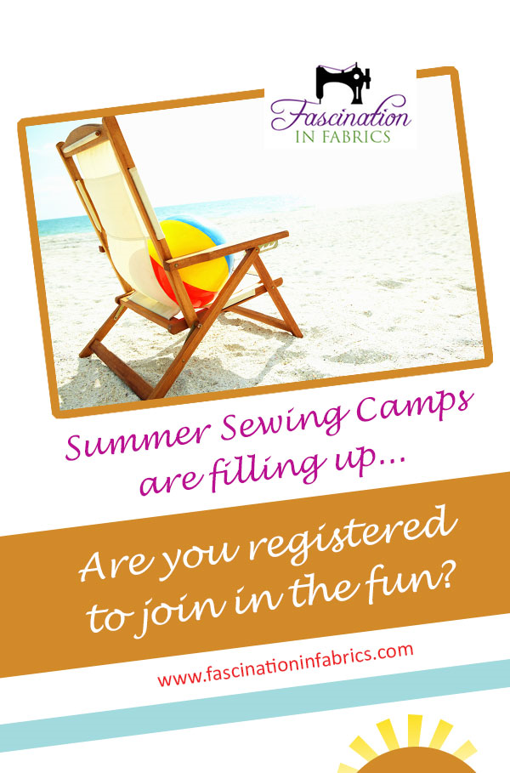

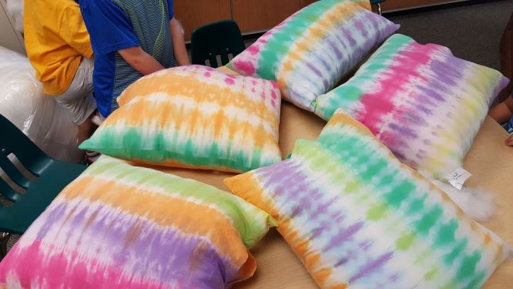
Summer Crafting Fun with Ms. Bobbi and Ms. Sharon
Join Ms. Bobbi Smith and Ms. Sharon Reynolds for a fun week trying some cool crafts! Learn beginning knitting skills, tie dye a piece of cloth to make into a bag, weave a bracelet or wall hanging, and create your very own Dreamcatcher to name a few of the crafts we’ll explore during the week.
June 10 – June 14
#101 Full Day 8:30 am – 3 pm $449
#102 Half Day (Mornings 8:30 am - 11:30 am) $249
#103 Half Day (Afternoons 12 pm – 3 pm) $249

July 15 – July 19
#104 Full Day 8:30 am – 3 pm $449
#105 Half Day (Mornings 8:30 am – 11:30 am) $249
#106 Half Day (Afternoon 12 pm – 3 pm) $249

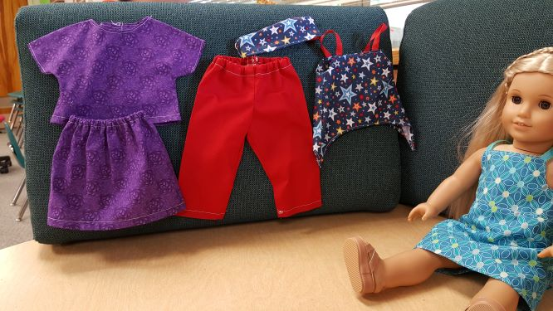
Sewing for your American Girl Doll
Whether you’re a beginner or advanced sewer, spend a week making clothes and accessories for your American Girl Doll. More advanced sewers can choose to use a pattern to make the garments of their choice. A wonderful week for sewing for your doll and stitching with friends! Bring your doll, of course!
June 17 – June 21
#107 Full Day $449 8:30 am – 3 pm
#108 Half Day (Mornings 8:30 am – 11:30 pm) $249
#109 Half Day (Afternoons 12 pm – 3 pm) $249

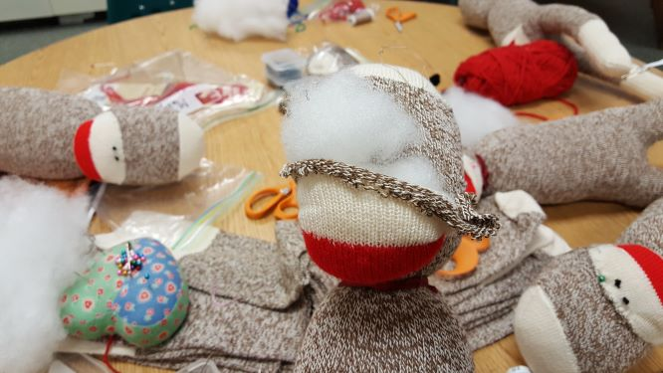
Monkey Business
By popular demand, Ms. Bobbi will help campers bring a red heel pair of socks to life as they create their very own sock monkey! No two sock monkeys are quite alike! By the end of the week you’ll have very own sock monkey to love (and any accessories and clothes we have time to make)!
June 24 – June 28
#110 Full Day $449 8:30 am – 3 pm
#111 Half Day (Mornings 8:30 am – 11:30 am) $249
#112 Half Day (Afternoons 12 pm – 3 pm) $249

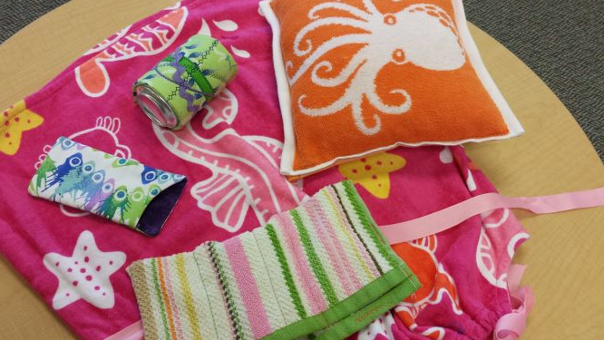
Summer Sewing on the Go -Sewing for the Beach!
Summer “Sewing on the Go” is a fun filled class jam packed with lots of cool projects to make and take and this week we will be focusing on sewing projects we can take to the beach! Learn to navigate the sewing machine and understand lots of sewing terms and techniques. Sharpen your embellishment and embroidery skills and let your creativity take over to personalize all your projects. Classes are tailored to the sewing knowledge of participants in each class.

July 8 – July 12
#113 Full Day $449 8:30 am – 3 pm
#114 Half Day (Mornings 8:30 am – 11:30 am) $249
#115 Half Day (Afternoons 12 pm – 3 pm) $249

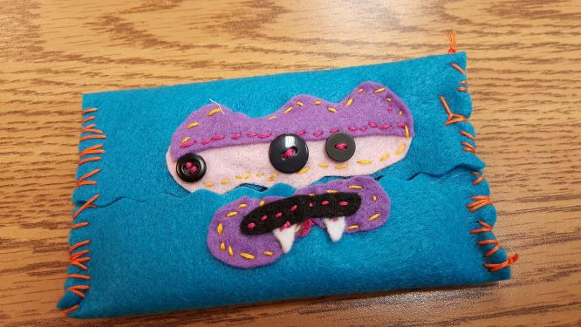

Creature Camp

Explore the world of soft sculpture as you create your very own stuffed animals from start to finish. Learn to use a sewing pattern and perfect new sewing skills. Explore your creative side as you create these lovable creatures and personalize them with clothes and accessories. Get ready for a full week of sewing fun!

July 29 – August 2
#116 Full Day $449 8:30 am – 3 pm
#117 Half Day (Morning 8:30 am – 11:30 am) $249
#118 Half Day (Afternoon 12 pm – 3 pm) $249

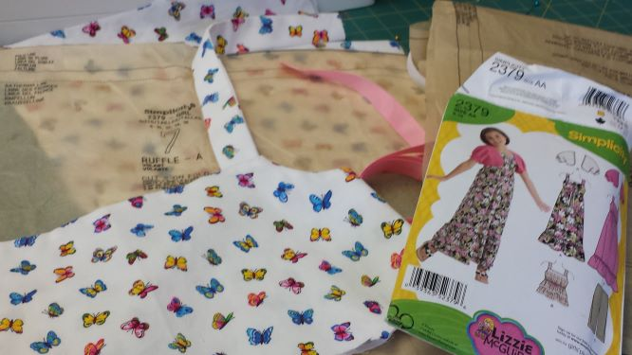

Sewing with Commercial Patterns

In this fun filled week begin to learn all the ins and outs of using a commercial pattern from start to finish. Make a robe and Pajama pants, a skirt and top, or a stuffed animal to cuddle! Or how about a bookbag for back to school? One thing is for sure, at the end of the week you can say to everyone, “I made it myself!”

August 5 – August 9
#119 Full Day $449 8:30 am – 3 pm
#120 Half Day (Mornings 8:30 am – 11:30 am) $249
#121 Half Day (Afternoons 12 pm – 3 pm) $249

Summer Crafting with Ms. Bobbi and Ms. Sharon
June 10 – June 14
#101 Full Day (8:30 am – 3 pm) $449 _________
#102 Half Day (8:30 am – 11:30 am) $249 _________
#103 Half Day (12 pm – 3 pm) $249 _________

July 15 – July 19
#104 Full Day (8:30am – 3 pm) $449 _________
#105 Half Day (8:30 – 11:30 am) $249 _________
#106 Half Day (12 pm – 3pm) $249 _________

Sewing for Your American Girl
June 17 – June 21
#107 Full Day (8:30 am – 3 pm) $449 ________
#108 Half Day (8:30 am – 11:30 am) $249 _________
#109 Half Day (12 pm – 3 pm) $249 _________

Monkey Business
June 24 – June 28
#110 Full Day (8:30 am – 3 pm) $449 _________
#111 Half Day (8:30 am – 11:30 am) $249 _________
#112 Half Day (12 pm – 3 pm) $249 _________

Summer Sewing on the Go – Sewing for the Beach
June 24 – June 28
#113 Full Day (8:30 am – 3 pm) $449 __________
#114 Half Day (8:30 am – 11:30 am) $249 __________
#115 Half Day (12 pm – 3 pm) $249 __________

Creature Camp
July 29 – August 2
#116 Full Day (8:30 am – 3 pm) $449 _________
#117 Half Day (8:30 am – 11:30 am) $249 _________
#118 Half Day (12 pm – 3 pm) $249 _________

Sewing with Commercial Patterns
August 5 – August 9
#119 Full Day (8:30 am – 3 pm) $449 __________
#120 Half Day (8:30 am – 11:30 am) $249 __________
$121 Half Day (12 pm – 3 pm) $249 __________

Payment and Personal Information

Master Card ______ Visa _______
Account Number ___________________________
Expiration Date____________________________
Name on Card______________________________

Check______
Check Number_______
Make check out to “Fascination in Fabrics”

Personal Information

Name of Sewer____________________________________
Age________ Grade____________
Sewing Experience
0-1 year____ 1 – 3 years______ over 3 years_____
Parents Name______________________________________
Address__________________________________________
___________________________________________
____________________________________________
Phone
Home________________________________
Cell__________________________________
Email____________________________________________

Send registrations to:

Bobbi Smith
3008 Larkin Rd
Upper Chichester, PA 19061
BobbiS@fascinationinfabrics.com

